**Game Concept 1:**

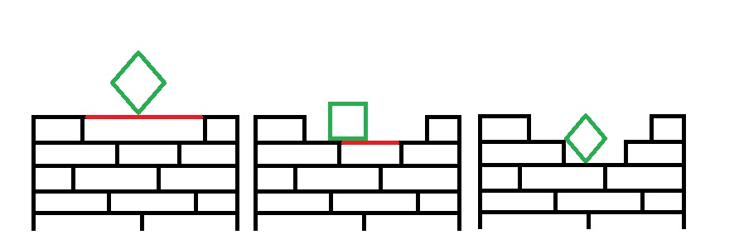

The first concept is a form of Jenga but instead of removing blocks you remove lines from a structure. Each player takes their turn removing a line each, the less time spent and the higher the drop of the block the more points you earn.   
  
The win condition is to get the green block to the bottom of the pile without falling out from the sides. The player with the higher score wins.

**Game Concept 2:**

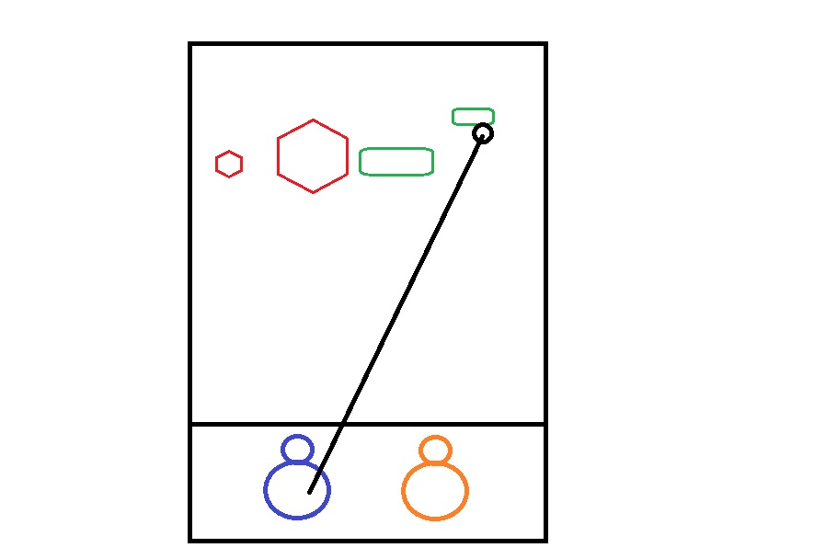

My second game concept involves a hook mechanic that’s very popular with ARTS/MOBA games. Each player takes their turn trying to hook a small object from the other side of the screen.

The challenge is that the hook moves slow and the blocks they’re trying to hook move fast. Upgrades for the speed of the hook and the size of it can be implemented in the form of blocks you can hook.

The win condition is score after a set number of turns have been played. The smaller the blocks the higher the score.  
  
This game offers a lot of room for improvement in the form of different blocks that have different mechanics.